PERSONAL PROFILE

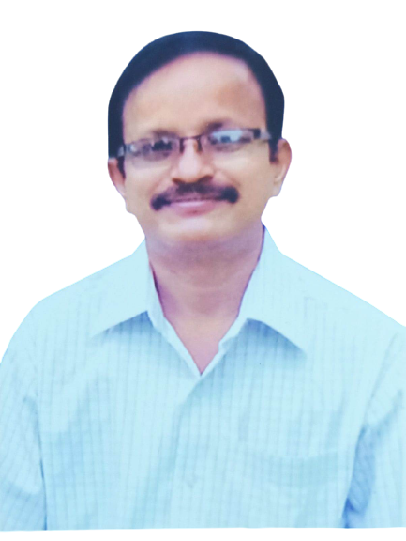

Dr.v.suryanarayana
M.a., net, p.hd

Lec in history
Dr.v.s.krishna GOVT.DEGREE & pg COLLEGE
VISAKHAPATNAM

- GENERAL INFORMATION:

NAME : dr.v.suryanarayana
Address : s/o ramunaidu
Mallam palem village
Chowduvada h.o
k.kotapadu
visakhapatnam– 531034
Designation : LEC IN history
Department : dept. of history
Date of birth : 01-07-1967
Area of specialization: Indian history &
History of modern japan
CONTACT NO : 7013485425
EMAIL : v.suryanarayana96@gmail.com

- Academic qualifications:

Exam  Passed | Board/  University | Subject | Year | Division/  Grade
Master degree | m.a - au | History | 1994 | Ii class
Research degree | P.hd - au | The role of justice party in the emergence of dominant caste political culture in ap: a study in social and political history | 2020 | I class
net | Apcsc | History | 1996

- Research experience:

Research  Stage | Title of work/dissertation | University
Ph.D | The role of justice party in the emergence of dominant caste political culture in ap: a study in social and political history | Andhra university

